It has been months since we first started Social Distancing and it is beginning to get to people emotionally. Emotions such as anger, boredom, irritability, grumpiness, disappointment, weepiness and even fear are common emotions during times of stress. Very often we don’t know what we are feeling, just that we are out of sorts and we can get caught up in the feeling or try to shut it down. Feelings are a part of being a human being. We all have them. Acting out or pushing away these emotions usually creates tension within ourselves and then we frequently blame others, yell, get depressed, feel anxious or may be even suicidal. These times have brought up the awareness that we don’t have control.
Marriages are challenged as couples cope with children at home all day, home schooling and both parents are trying to work. They may be feeling isolated. One or more adults may be out of work raising financial concerns. One person may be a first responder triggering a lot of anxiety about contagion. Tension is likely to be a part of every day. We may have coped up until now but our coping skills are being challenged and blame, arguing and yelling are becoming more prevalent. When we feel out of control we may turn to alcohol, smoking or use of prescription or illegal drugs.
Marriages that were struggling before Covid-19 feel the strain more intensely than those whose marriages that were more stable. Esther Perez, a noted Marital Therapist predicted that there will be more divorces and more babies after Covid-19.
Children who pick up parental tension may start to behave in ways that may not have been seen before, and other, difficult behaviors may increase. Below are some practical resources that may help coping in your family:
- Establish a FAMILY MEETING and ask each member to attend. Be sure you choose a time when everyone will be rested, well fed and not feeling pressured because of a project. As the architects of the family, be certain that you know what you are feeling and feel able to manage your feelings. Children are very perceptive and peace and calm are contagious. As the parent you can structure the meeting but essential rules are listening, no interrupting, no ridiculing etc. You might set a three minute time for each one to speak their feelings or wishes for activities. Make this an opportunity for each one to feel heard.
- Suggestions for meeting time:
  - Learn and Teach Square Breathing. This a technique that you can use and teach everyone and they can use it for life.
  - Color YOUR Heart - each person gets the opportunity to color their heart based on the color of a feeling. (Resource at bottom)
  - Ask each one to tell a joke or share a story, etc.
  - Ask each to express something that they are grateful for.

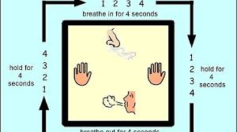

  - Call a THERAPIST if you feel overwhelmed. Most therapists are now doing TELETHERAPY
  - Tell STORIES to your children to help them cope with this new reality.
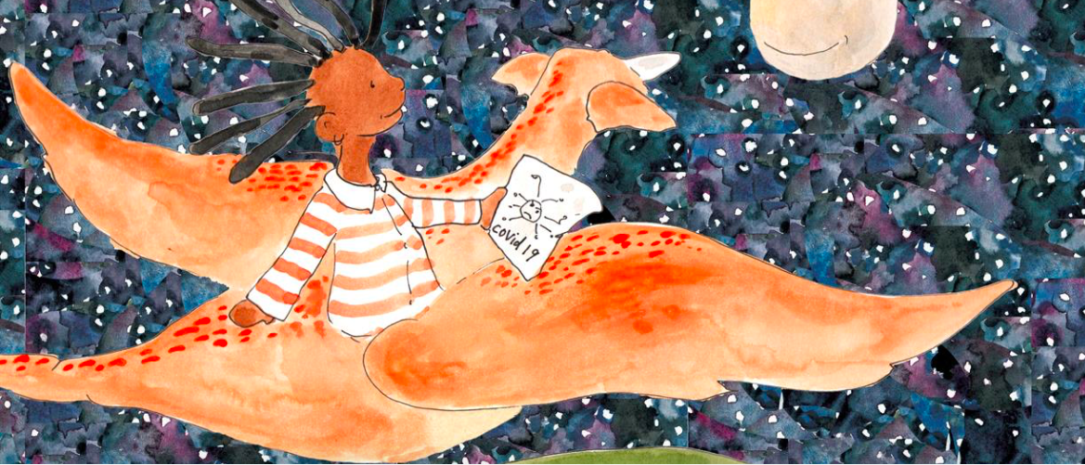
  - NY Times has many articles on ways to cope during Covid-19 (do not need a subscription)
  - The New York Times offers free publications to help people cope with COVID 19. Among them is THIS
NYT Opinion pieces can be found HERE
  - Resources for VETS and their families see below.
  - If you need more help in coping with the current crisis, please call us at (877) 727- 6283 to be referred to a Psychiatric APN
  - Resources for VETS and their families see below.

